EKG VE HASTABAŞI MONİTÖRLERİNE
AİT SARF MALZEME RESİMLERİ
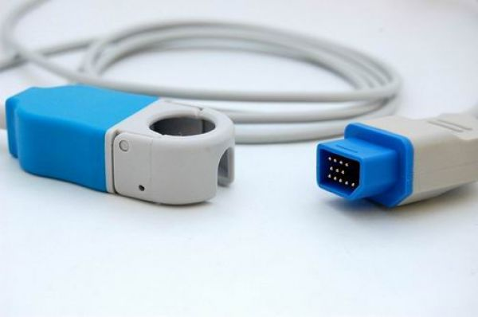NIHON KOHDEN SPO2 ARA KABLOSU
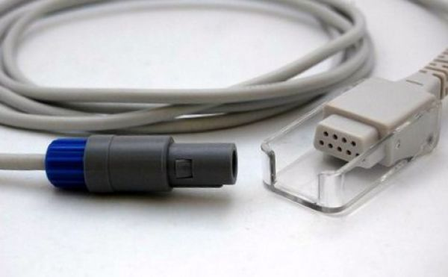

GOLDWAY SPO2 ARA KABLOSU

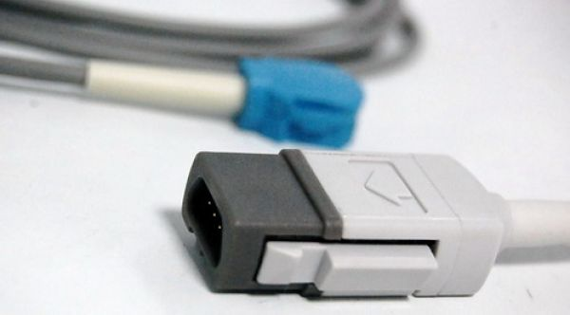GE-DATEX OHMEDA SPO2 ARA KABLOSU

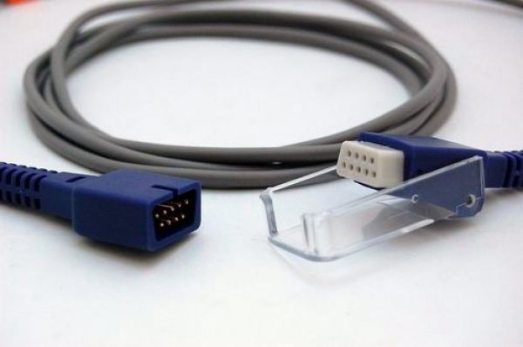NELLCOR OXIMAX SPO2 ARA KABLOSU

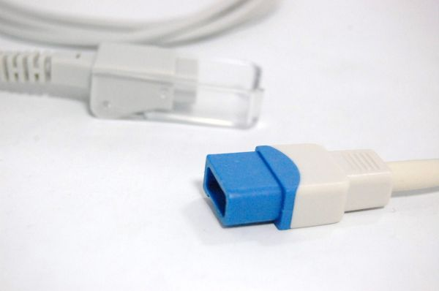SPACELABS SPO2 ARA KABLOSU

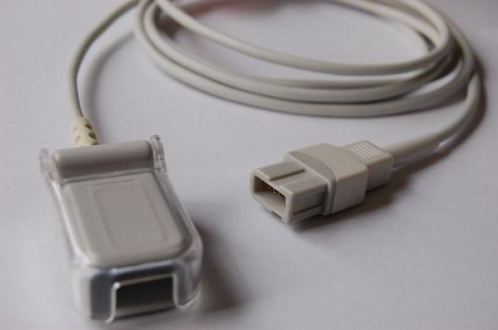SPACELABS SPO2 ARA KABLOSU

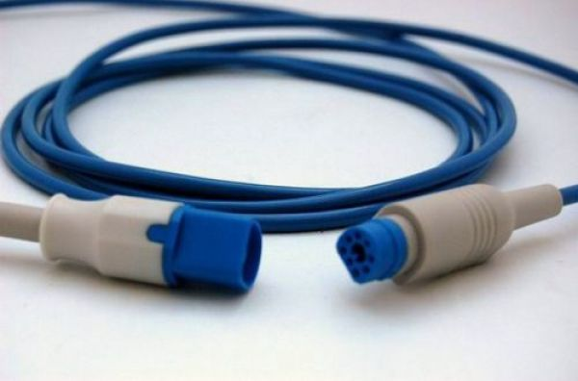PHILIPS SPO2 ARA KABLOSU

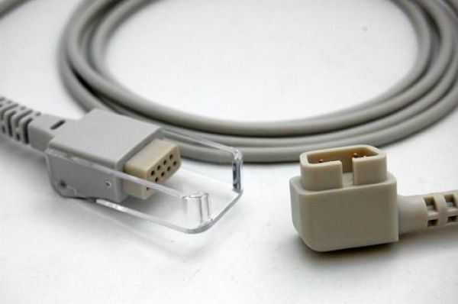CRİTİCARE SPO2 ARA KABLOSU
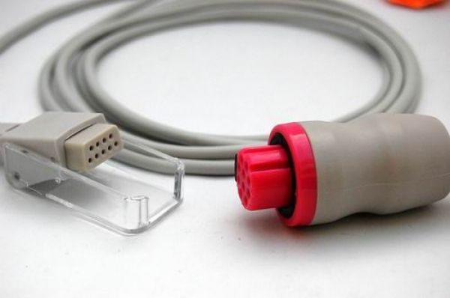ARTEMA SPO2 ARA KABLOSU

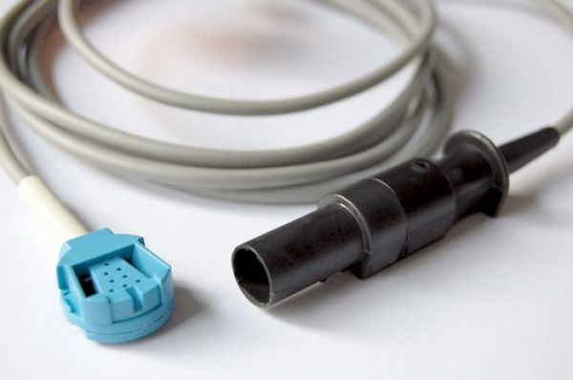GE MARQUETTE SPO2 ARA KABLOSU
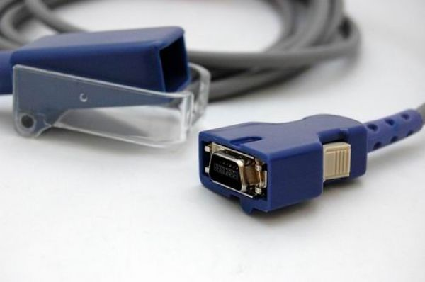NELLCOR SPO2 ARA KABLOSU

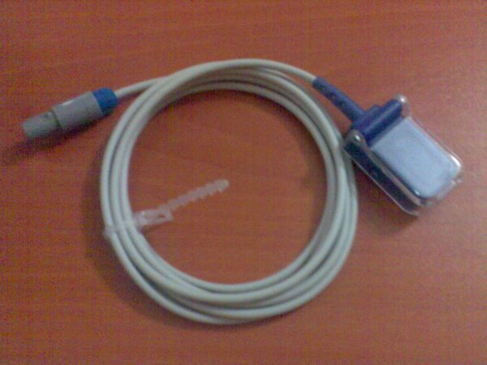PRİMEDİC SPO2 ARA KABLOSU (OXIMAX)
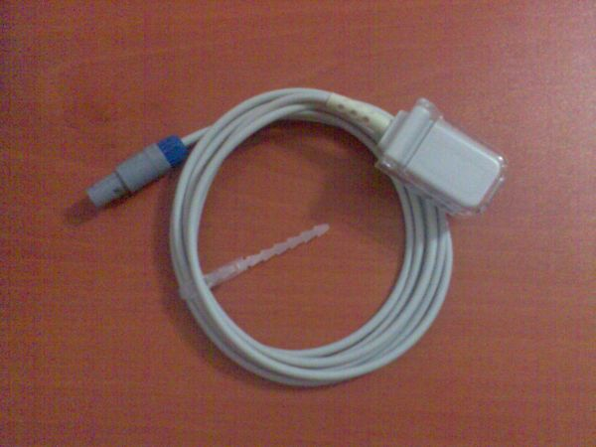PRIMEDIC SPO2 ARA KABLOSU (NELLCOR)
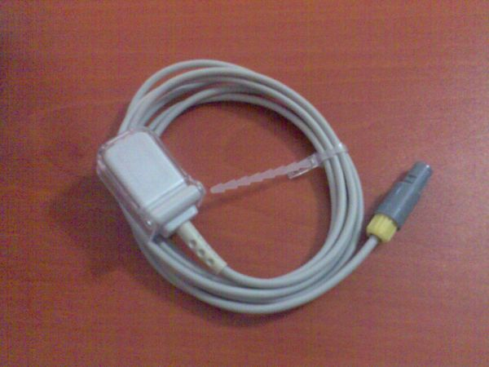PETAŞ SPO2 ARA KABLOSU
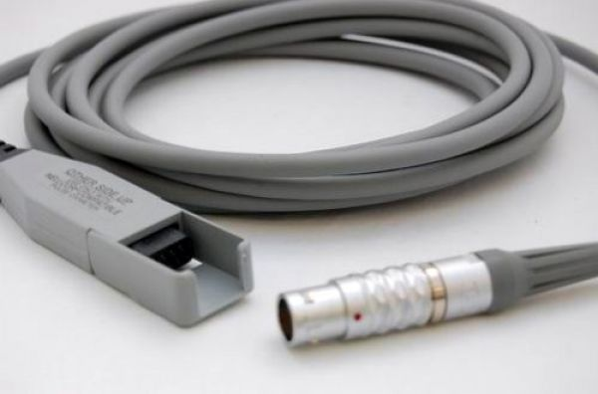

NELLCOR SPO2 ARA KABLOSU (12 PİN)

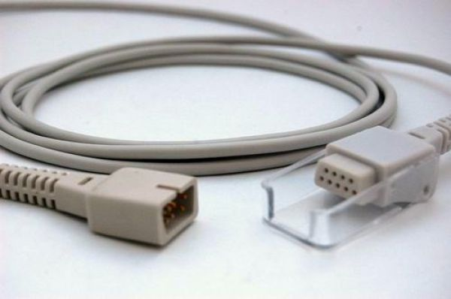

NELLCOR SPO2 ARA KABLOSU
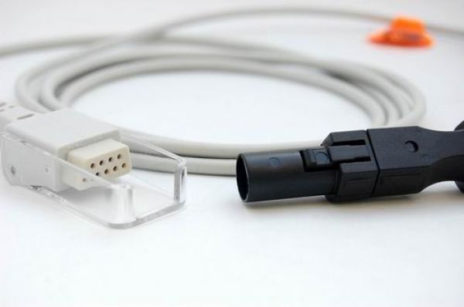
SPACELABS SPO2 ARA KABLOSU

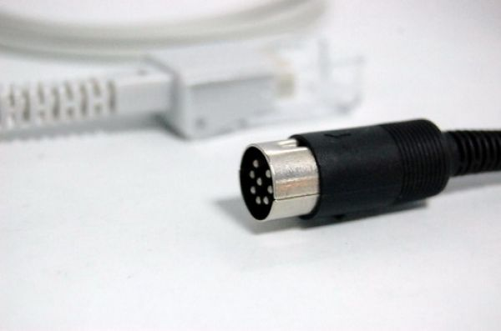DATASCOPE SPO2 ARA KABLOSU
NONIN SPO2 ARA KABLOSU

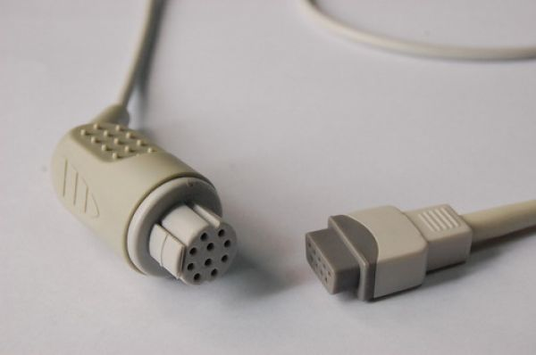GE DATEX OHMEDA SPO2 ARA KABLOSU
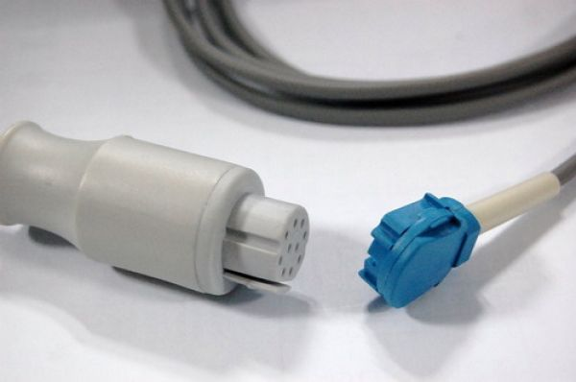GE DATEX OHMEDA SPO2 ARA KABLOSU

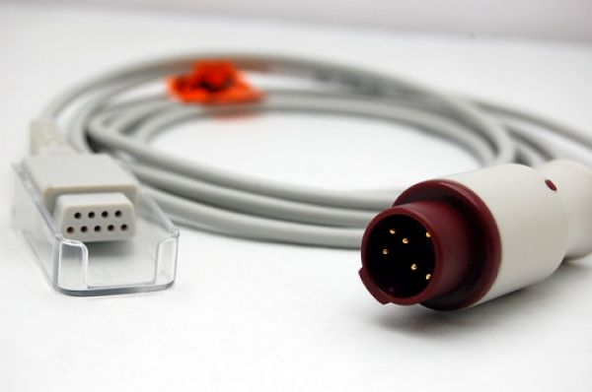KONTRON SPO2 ARA KABLOSU

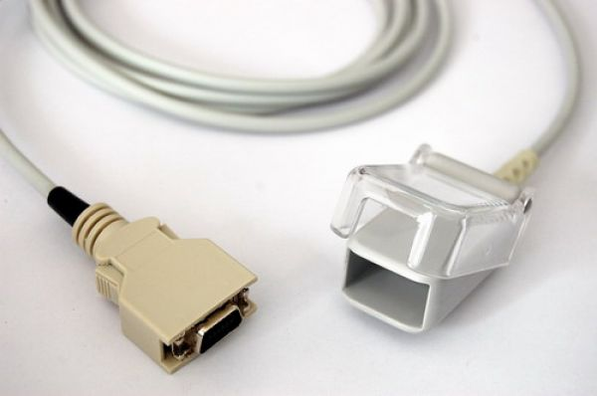MASIMO SPO2 ARA KABLOSU

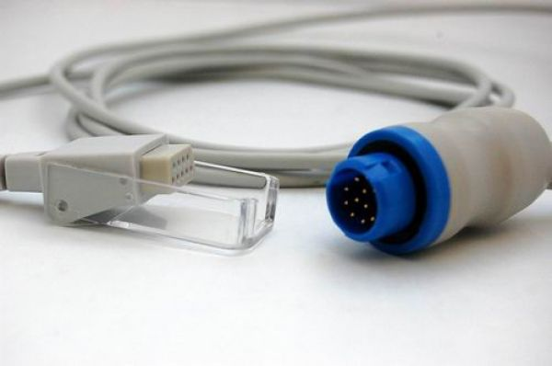MINDRAY SPO2 ARA KABLOSU
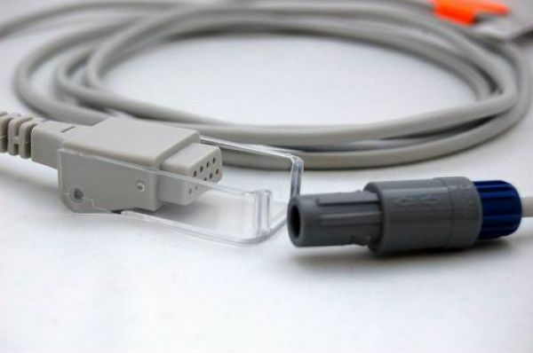MINDRAY SPO2 ARA KABLOSU

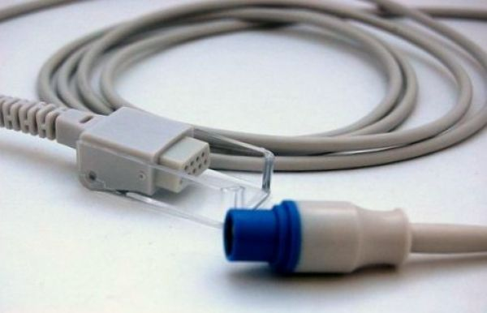DRAGER SIEMENS SPO2 ARA KABLOSU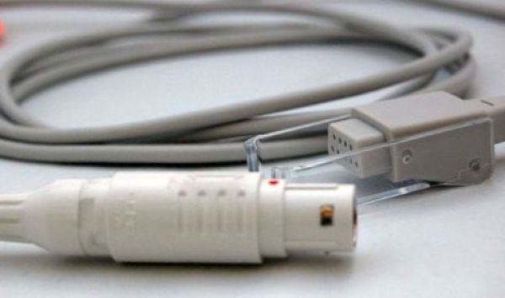DRAGER SIEMENS SPO2 ARA KABLOSU

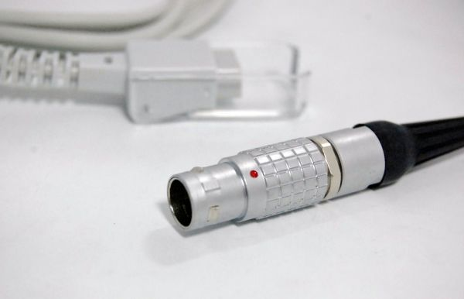MENNEN SPO2 ARA KABLOSU

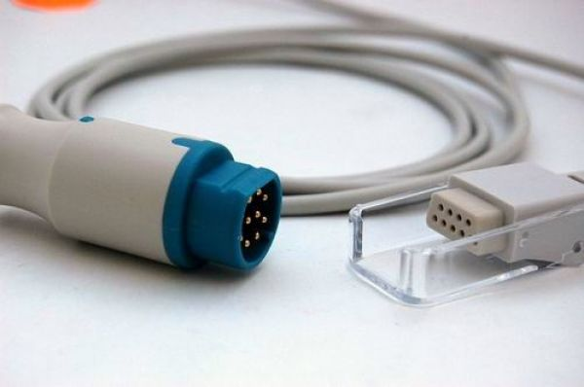SIEMENS SPO2 ARA KABLOSU

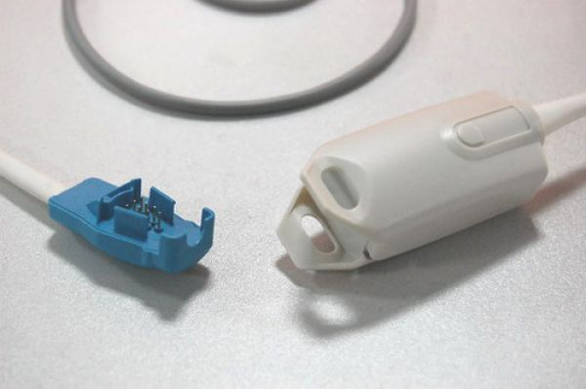

GE DATEX OHMEDA OXYTIP SPO2 PARMAK PROBU (ADULT)
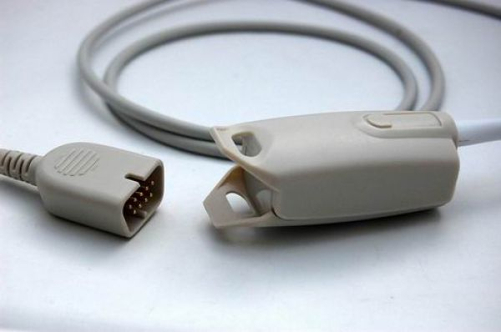

NIHON KOHDEN SPO2 PARMAK PROBU (ADULT)

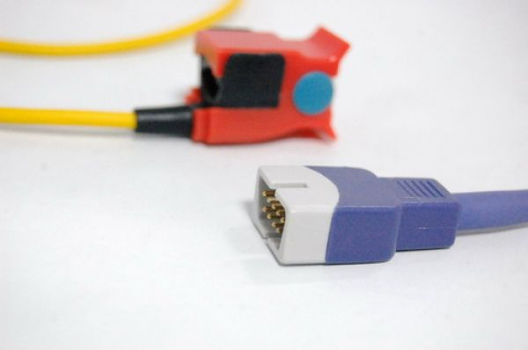

NELLCOR OXIMAX SPO2 PARMAK PROBU (PEDIATRIC)

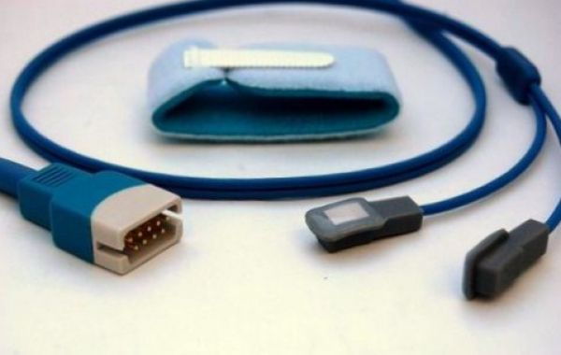

DATASCOPE SPO2 PROBU (Y SENSOR)

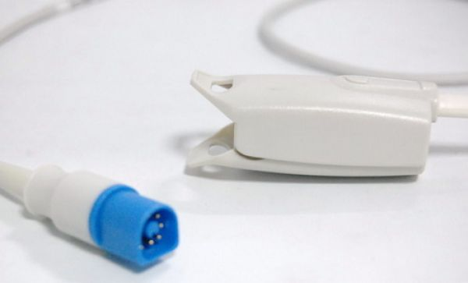

PHILIPS-HP SPO2 PARMAK PROBU (ADULT)
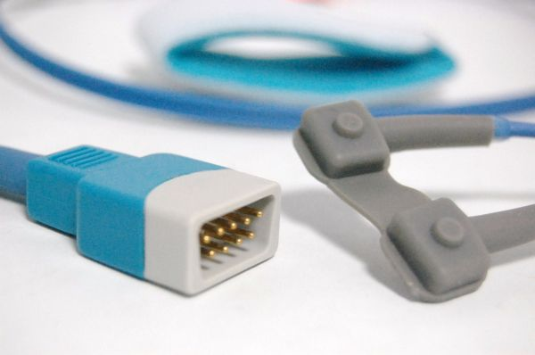

GE DATEX OHMEDA SPO2 WRAP PARMAK PROBU

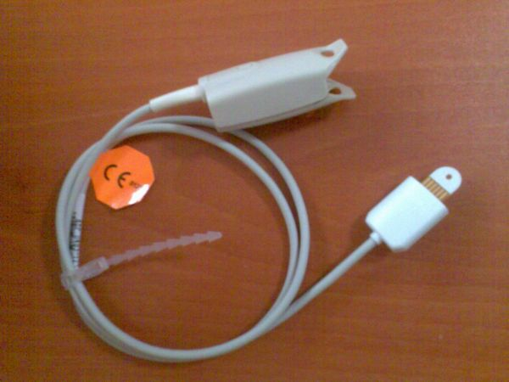

MASIMO SPO2 PARMAK PROBU (ADULT)

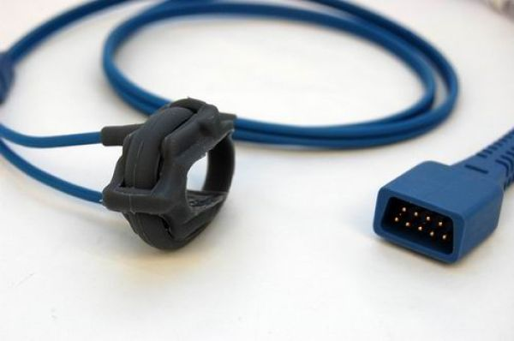

GE DATEX OHMEDA SPO2 WRAP PARMAK PROBU (NEONATE)

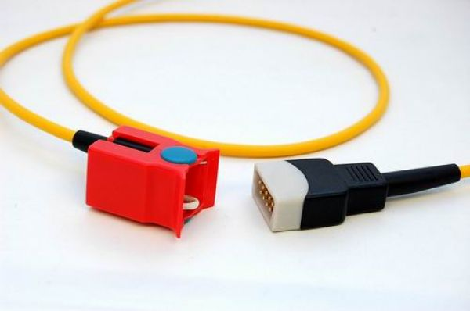

GE DATEX OHMEDA SPO2 PARMAK PROBU (PEDIATRIC)

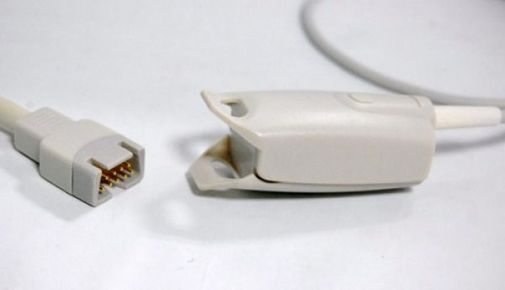

MASIMO SPO2 PARMAK PROBU (ADULT)

GE DATEX OHMEDA SPO2 WRAP PARMAK PROBU (NEONATE)

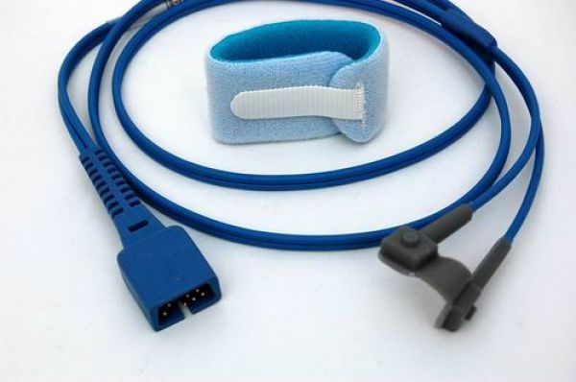

NELLCOR SPO2 WRAP PARMAK PROBU

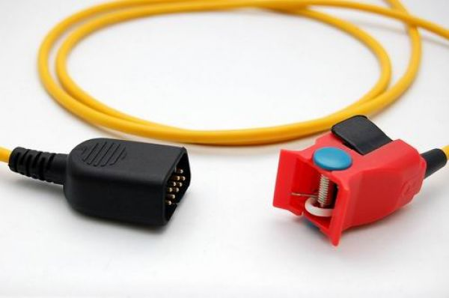

NIHON KOHDEN SPO2 KOMPLE PARMAK PROBU (PEDIATRIC)
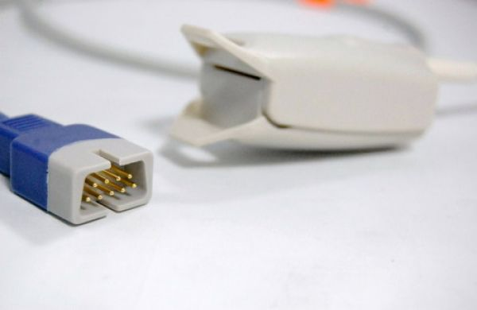

NELLCOR OXIMAX SPO2 PARMAK PROBU (ADULT)

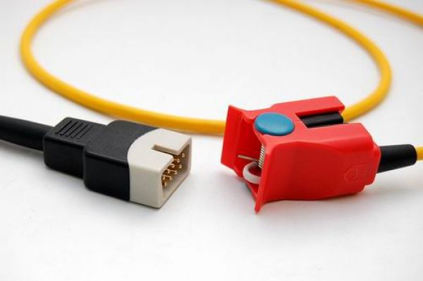
NELLCOR OXIMAX SPO2 PROBU PEDİATRİK (MANDALLI)
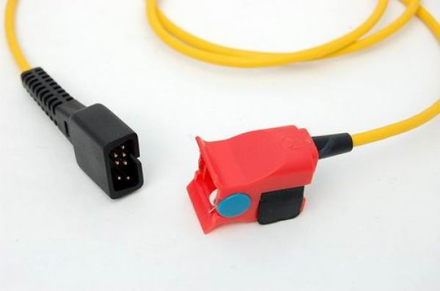
NELLCOR SPO2 PROBU PEDİATRİK (MANDALLI)

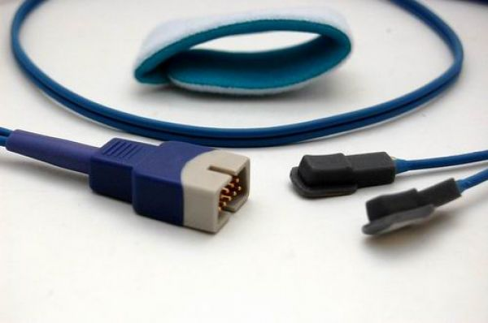NELLCOR OXIMAX SPO2 PROBU Y SENSOR
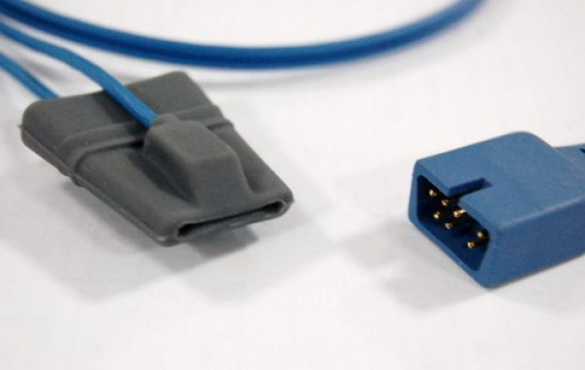DATASCOPE SPO2 PROBU ADULT SOFT TİP

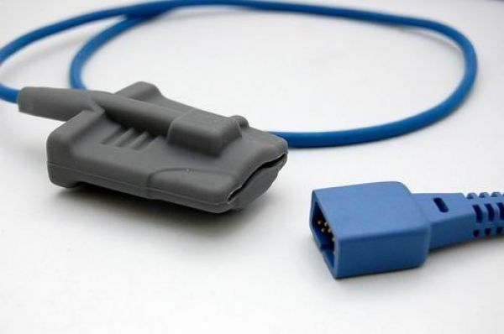

MEK SPO2 SOFT PARMAK PROBU (ADULT)

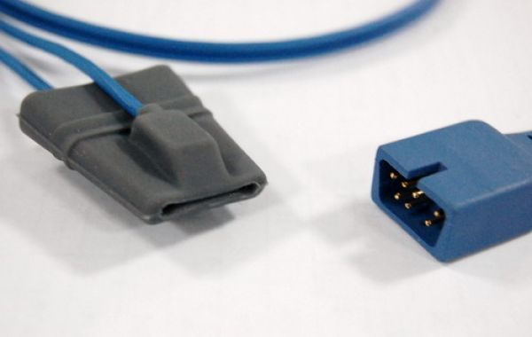

NELLCOR SPO2 SOFT PROB (PEDIATRIC)

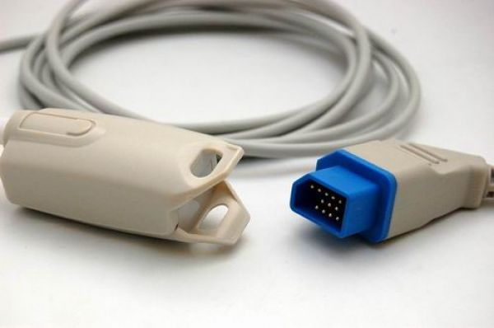

NIHON KOHDEN SPO2 KOMPLE PARMAK PROBU (ADULT)

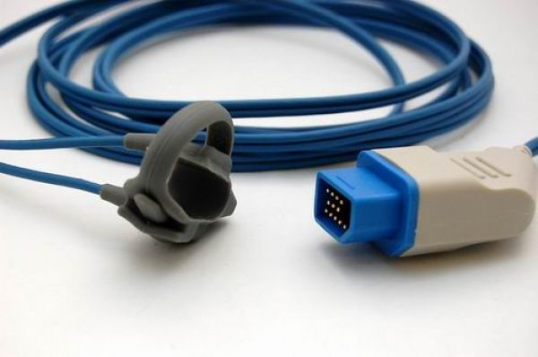

NIHON KOHDEN SPO2 KOMPLE WRAP PARMAK PROBU (NEONATE)

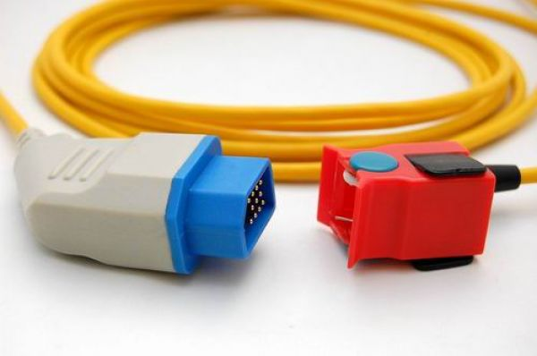

NIHON KOHDEN SPO2 KOMPLE PARMAK PROBU (PEDIATRIC)
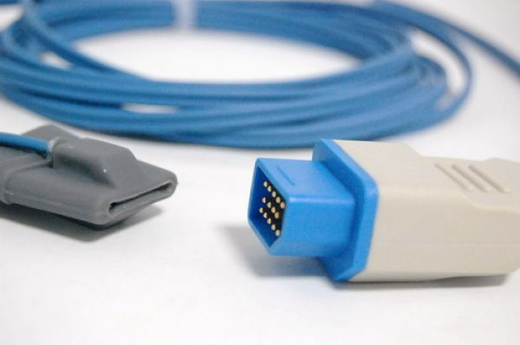

NIHON KOHDEN SPO2 KOMPLE SOFT PARMAK PROBU (PEDIATRIC)

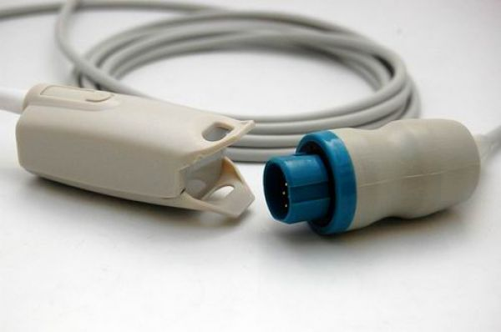

NIHON KOHDEN SPO2 KOMPLE PARMAK PROBU (ADULT)
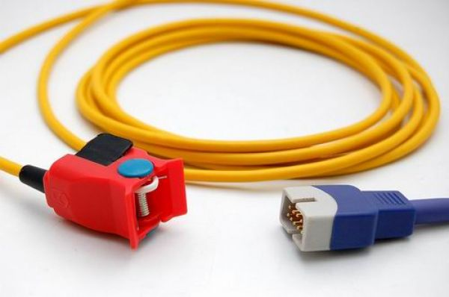

NELLCOR OXIMAX SPO2 KOMPLE PARMAK PROBU (PEDIATRIC)

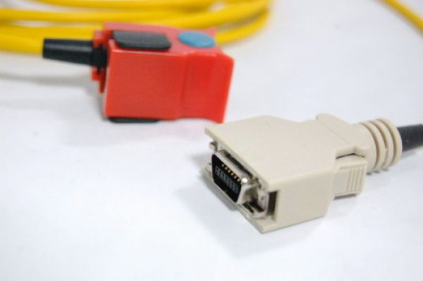

MASIMO SPO2 KOMPLE PARMAK PROBU (PEDIATRIC)

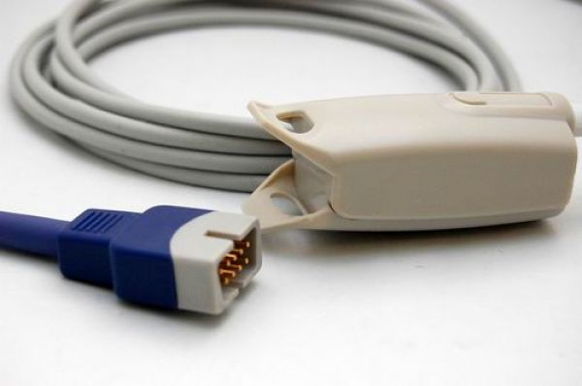

NELLCOR OXIMAX SPO2 KOMPLE PARMAK PROBU (ADULT)

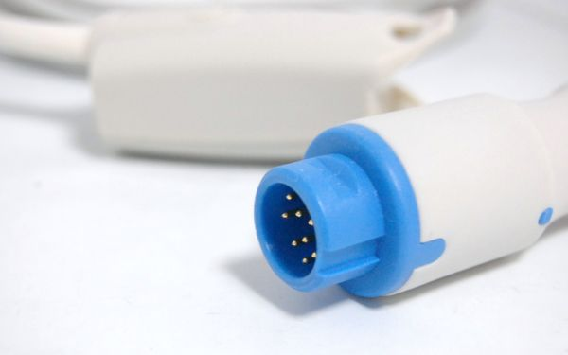

MINDRAY SPO2 KOMPLE PARMAK PROBU (ADULT)

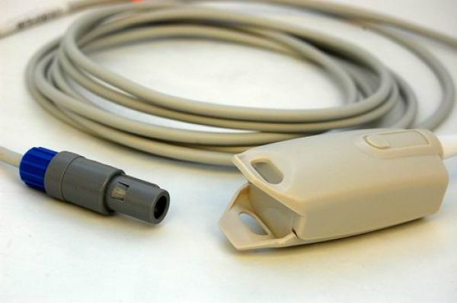

BIOLIGT SPO2 KOMPLE PARMAK PROBU (ADULT)

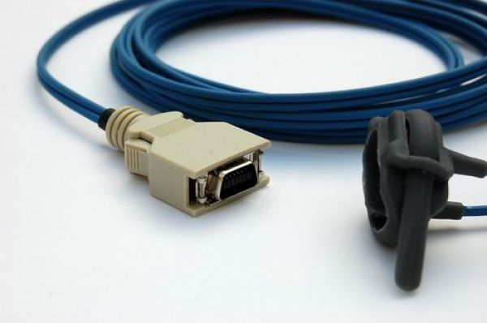

MASIMO SPO2 KOMPLE WRAP PARMAK PROBU (NEONATE)
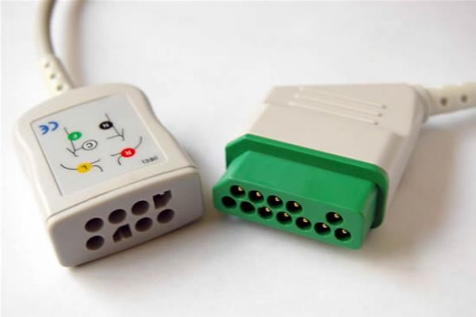NIHON KOHDEN EKG ARA KABLOSU (TRUNK CABLE IEC)

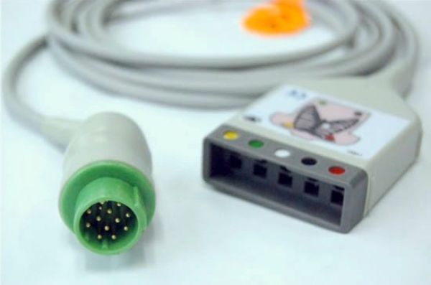MENNEN EKG ARA BALOSU (TRUNK CABLE IEC)

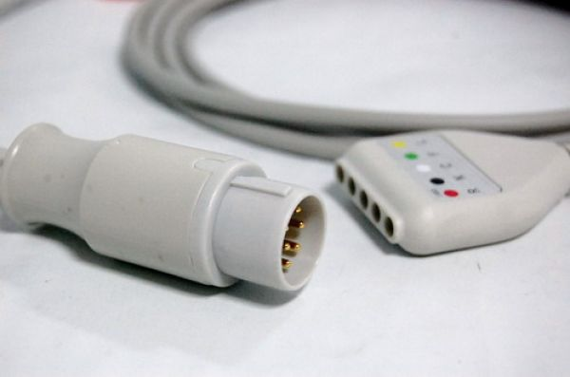MENNEN EKG ARA KABLOSU (DIN CABLE IEC)

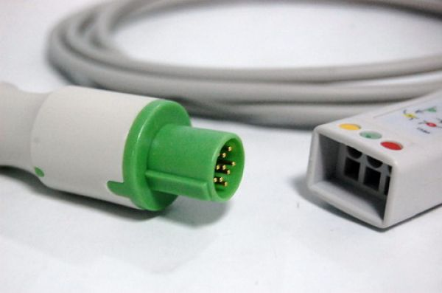GE HELLIGE EKG SPO2 ARA KABLOUSU ( TRUNK CABLE IEC)

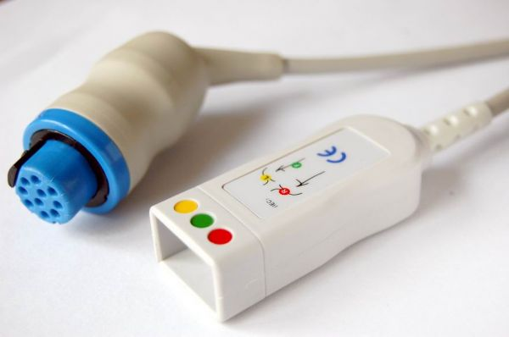GE DATEX OHMEDA EKG ARA KABLOSU (TRUNK CABLE IEC)

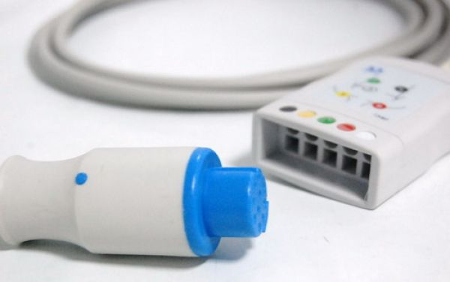GE DATEX OHMEDA EKG ARA KABLOSU (TRUNK CABLE IEC) 5 LEADS

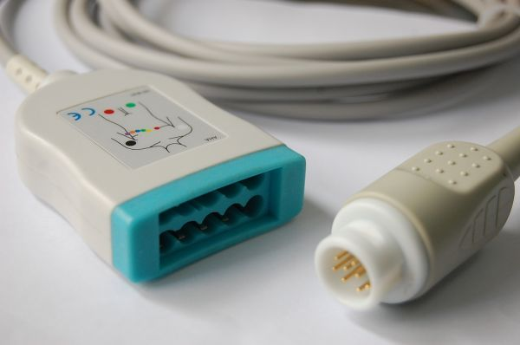PHILIPS HP EKG ARA KABLOSU (TRUNK CABLE AHA)

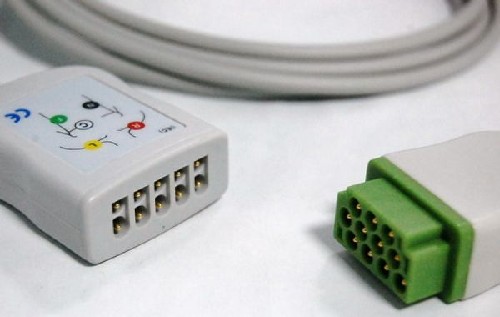GE MARQETTE EKG ARA KABLOSU (TRUNK CABLE IEC)

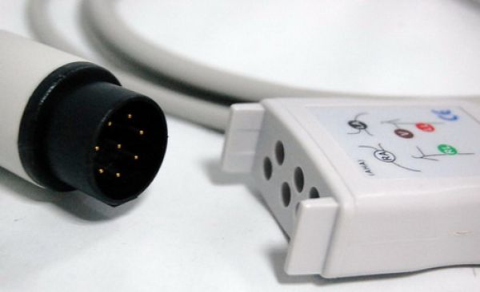NIHON KOHDEN EKG ARA KABLOSU (TRUNK CABLE AHA)

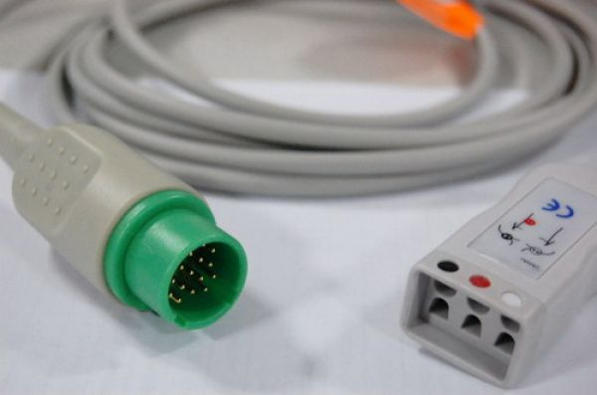SPACELABS EKG ARA KABLOSU (TRUNK CABLE AHA)
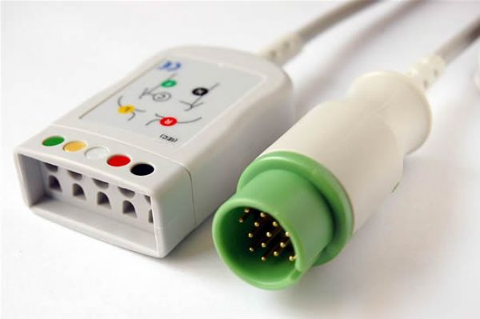SPACELABS EKG ARA KABLOSU (TRUNK CABLE IEC)

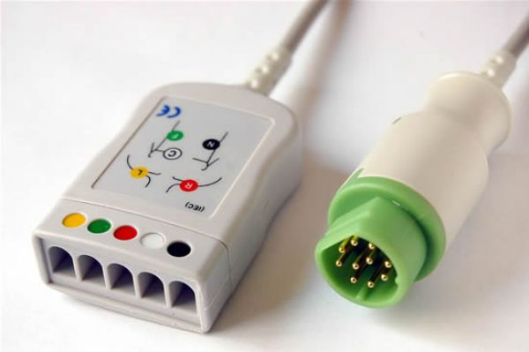SIEMENS EKG ARA KABLOSU (TRUNK CABLE IEC)

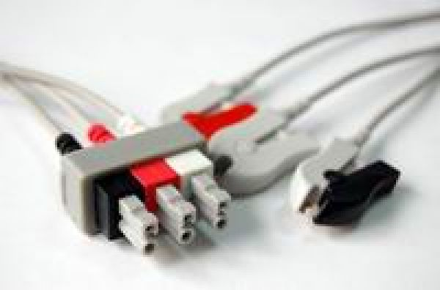

PHILIPS-HP EKG UÇ KABLOSU

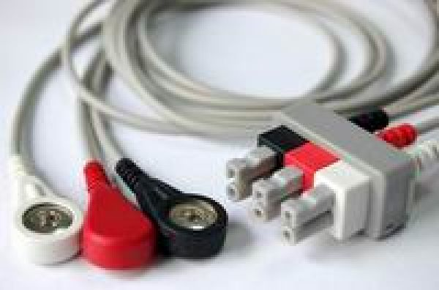
PHILIPS-HP EKG UÇ KABLOSU (SNAP-AHA)

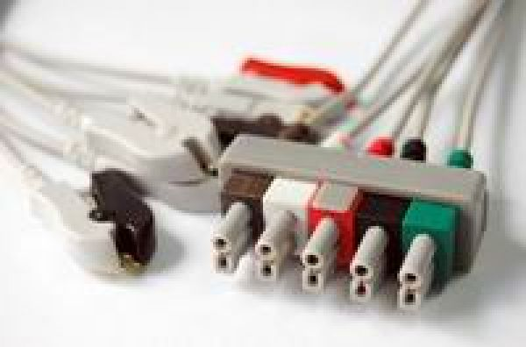

PHILIPS-HP EKG UÇ KABLOSU (GRABBER-AHA)

PHILIPS-HP EKG UÇ KABLOSU (GRABBER-AHA)

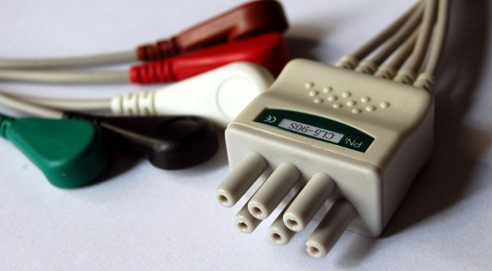

COLIN EKG UÇ KABLOSU (SNAP-AHA)

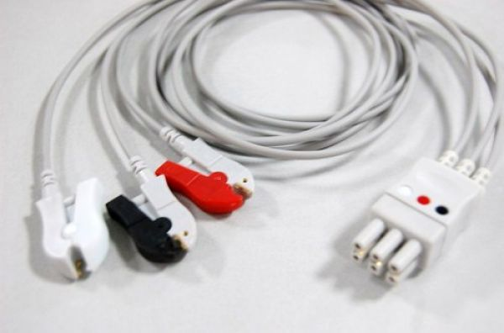

GE DATEX OHMEDA EKG UÇ KABLOSU (GRABBER-AHA)

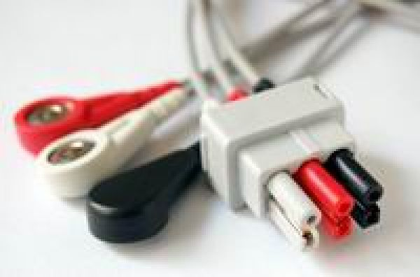

GE DATEX OHMEDA EKG UÇ KABLOSU (SNAP-AHA)

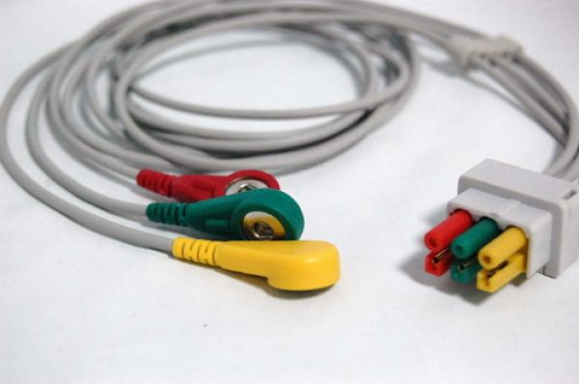

GE DATEX OHMEDA EKG UC KABLOSU (SNAP-IEC)

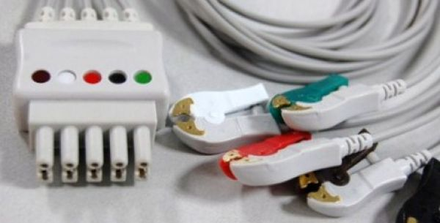

GE DATEX OHMEDA EKG UC KABLOSU (GRABBER-AHA)

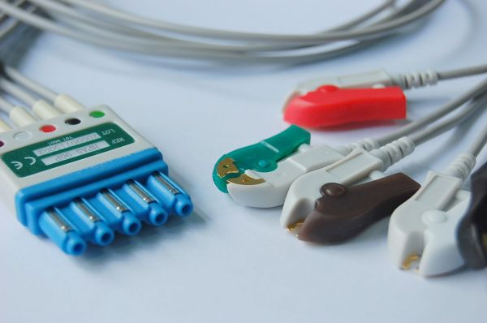
HP EKG LEAD

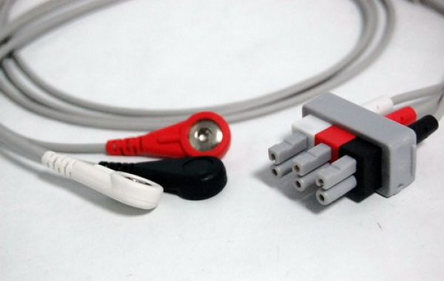
MENNEN EKG LEAD

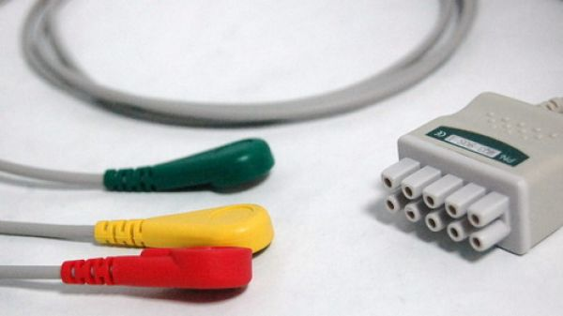
GE MARQETTE EKG LEAD ( SNAP IEC)

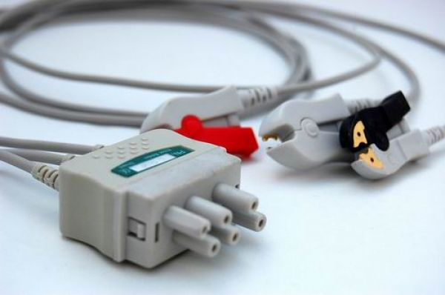
NIHON KOHDEN EKG LEAD (GRABBER AHA)

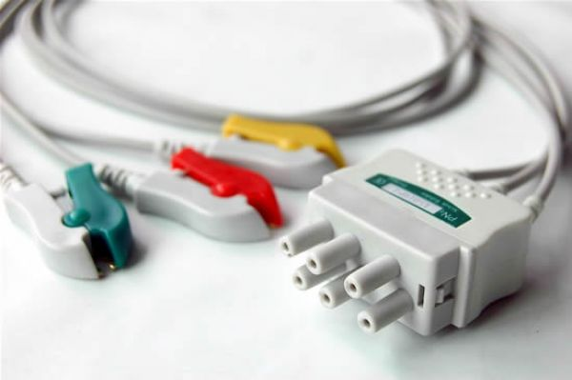
NIHON KOHDEN EKG LEAD (GRABBER IEC)

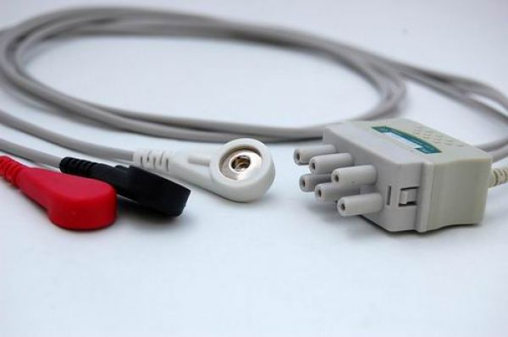
NIHON KOHDEN EKG LEAD ( SNAP AHA)

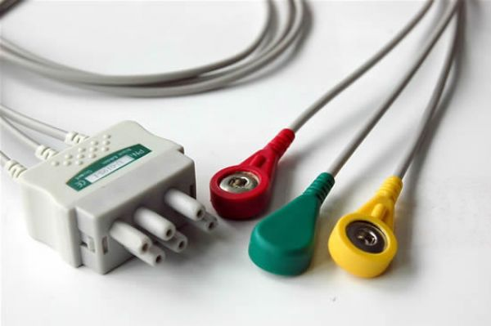
NIHON KOHDEN EKG LEAD ( SNAP IEC)

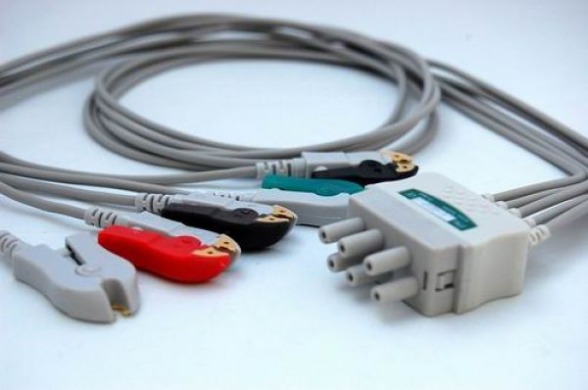
NIHON KOHDEN EKG LEAD (GRABBER AHA)

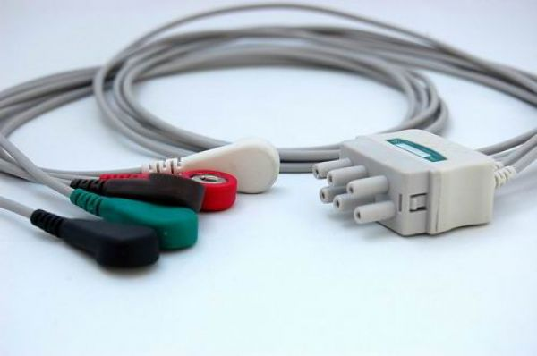
NIHON KOHDEN EKG UÇ KABLOSU (SNAP-AHA)

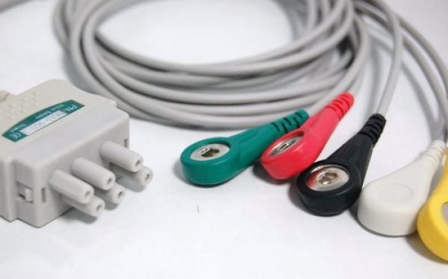

NIHON KOHDEN EKG UÇ KABLOSU (SNAP-IEC)

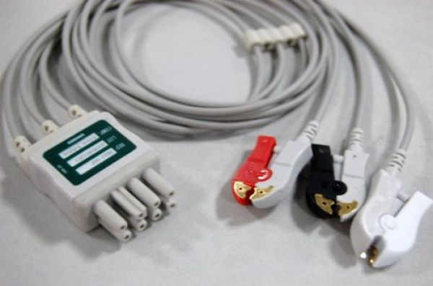

NIHON KOHDEN EKG UÇ KABLOSU (GRABBER-AHA)

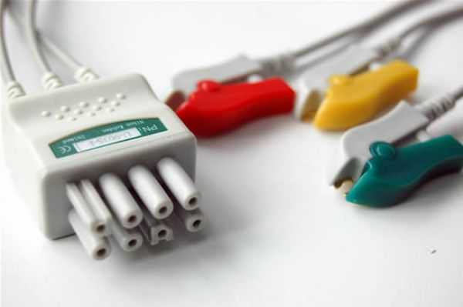

NIHON KOHDEN EKG UÇ KABLOSU (GRABBER-IEC)

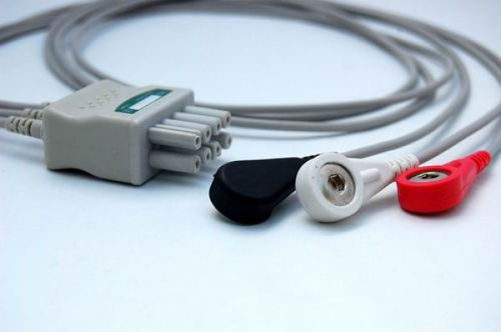

NIHON KOHDEN EKG UÇ KABLOSU (SNAP-AHA)

NIHON KOHDEN EKG UÇ KABLOSU (SNAP-IEC)

NIHON KOHDEN EKG UÇ KABLOSU (GRABBER-AHA)

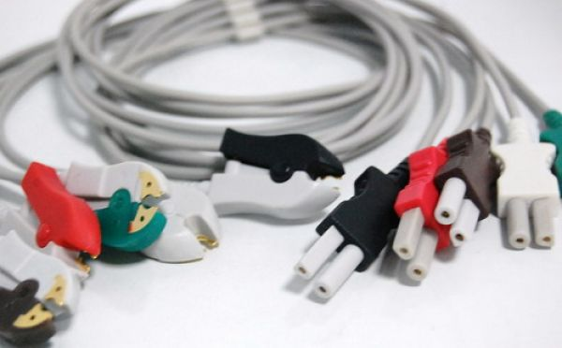

SPACELABS EKG UÇ KABLOSU (GRABBER-AHA)

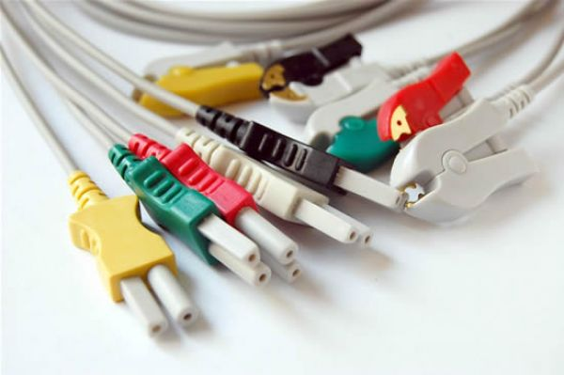

SPACELABS EKG UÇ KABLOSU (GRABBER-IEC)

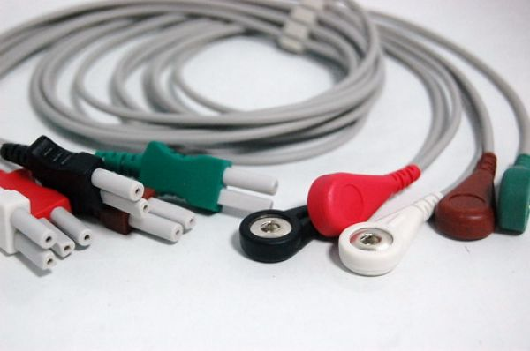

SPACELABS EKG UÇ KABLOSU (SNAP-AHA)

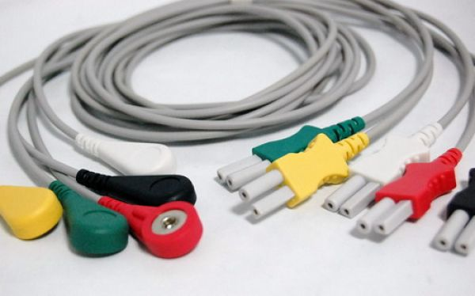

SPACELABS EKG UÇ KABLOSU (SNAP-IEC)

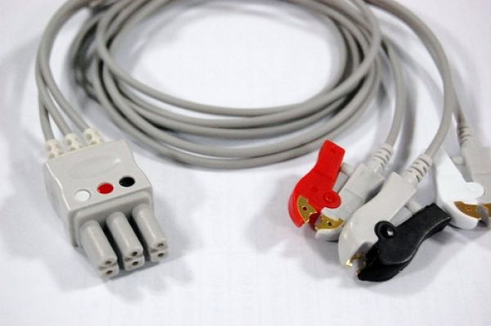

DRAGER-SIEMENS EKG UÇ KABLOSU (GRABBER-AHA)

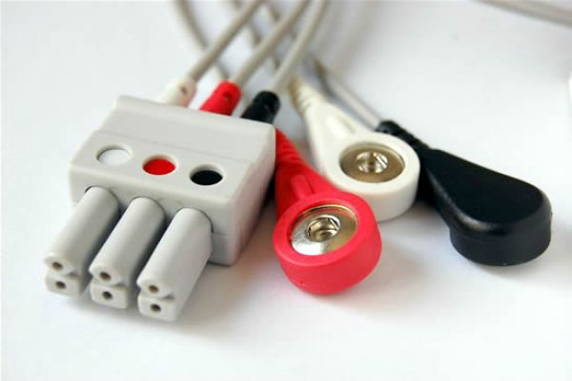

DRAGER-SIEMENS EKG UÇ KABLOSU (SNAP-AHA)

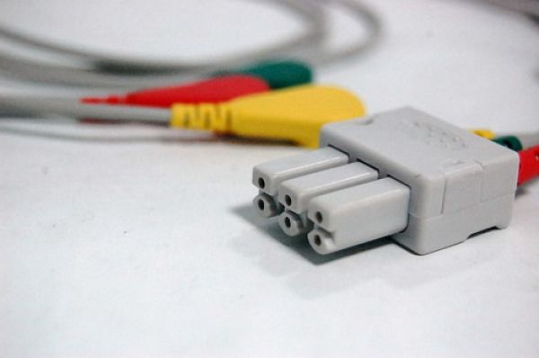

DRAGER-SIEMENS EKG UÇ KABLOSU (SNAP-IEC)

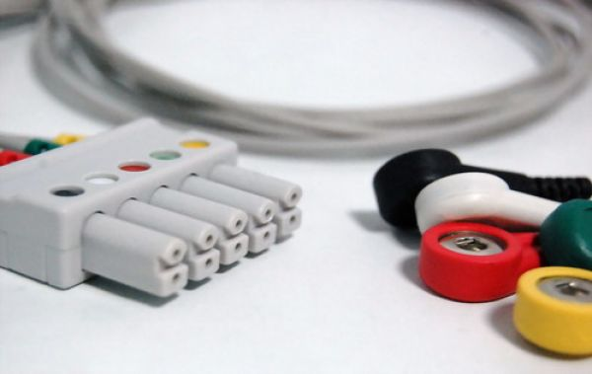

DRAGER-SIEMENS EKG UÇ KABLOSU (SNAP-IEC)

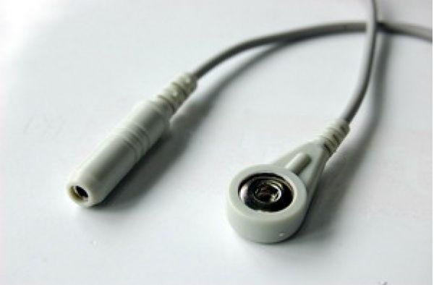
EKG ADAPTÖR KABLOSU 4 MM (BANANA SNAP 10 LU SET)

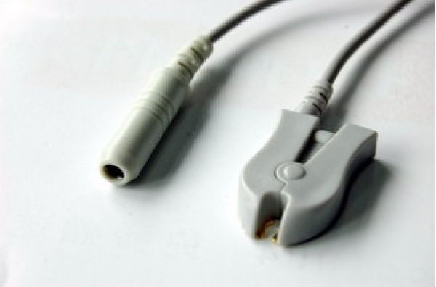
EKG ADAPTÖR KABLOSU 4 MM (BANANA BRABBER 10 LU SET)

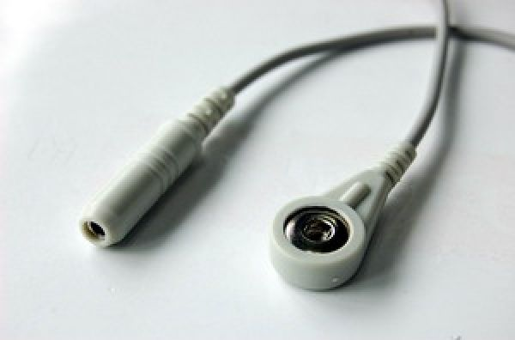
EKG ADAPTÖR KABLOSU ( 3 MM NEEDLE SNAP 10 LU SET)

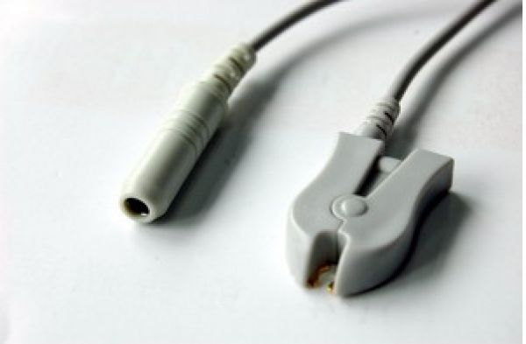
EKG ADAPTÖR KABLOSU ( 3 MM NEEDLE BRABBER 10 LU SET)

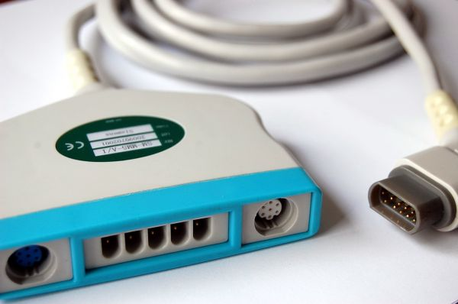DRAGER SIEMENS MULTIMED CABLE

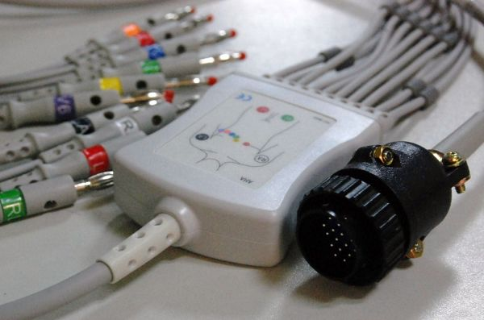
CARDIOLINE 10 LEAD EKG KABLOSU (4 MM BANANA AHA)

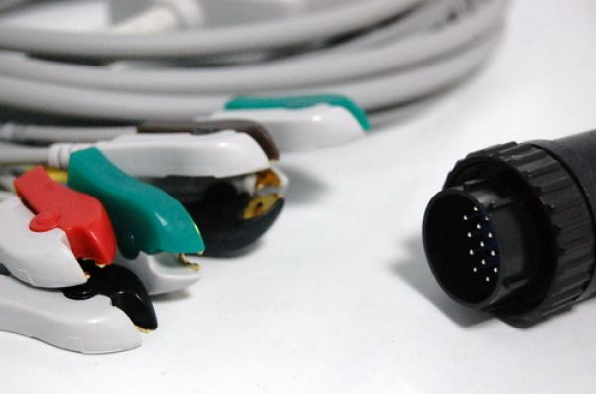

CARDIOLINE 10 LEAD EKG KABLOSU (GRABBER-IEC)

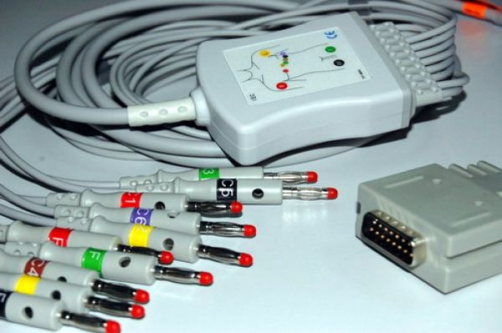
BURDICK 10 LEAD EKG KABLOSU (4MM BANANA-IEC)

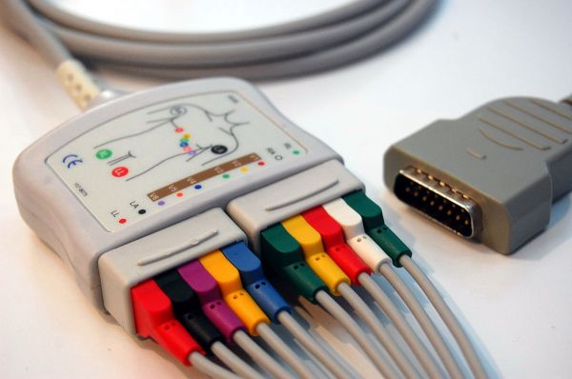

GE MARQUETTE 10 LEAD EKG KABLOSU VE LEAD TAKIMI

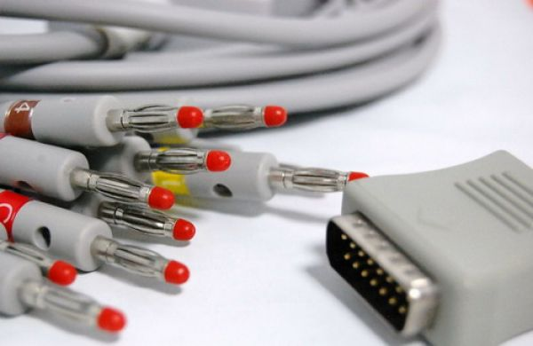

NIHON KOHDEN 10 LEAD EKG KABLOSU (4MM BANANA-IEC)

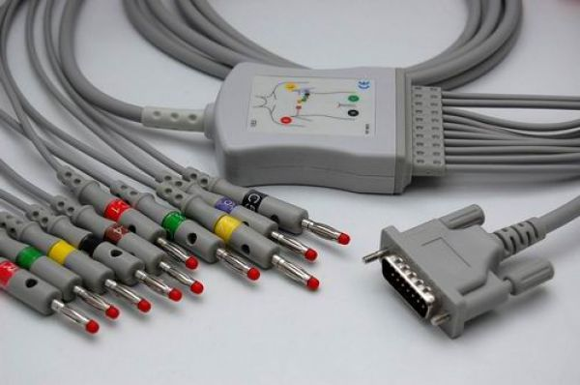

NIHON KOHDEN 10 LEAD EKG KABLOSU (4MM BANANA-IEC)

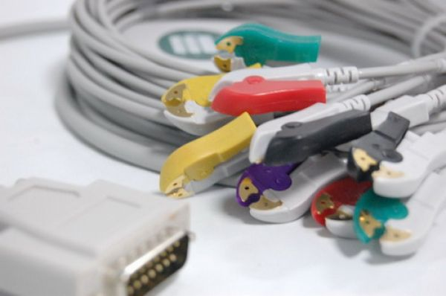

NIHON KOHDEN 10 LEAD EKG KABLOSU (GRABBER-IEC)

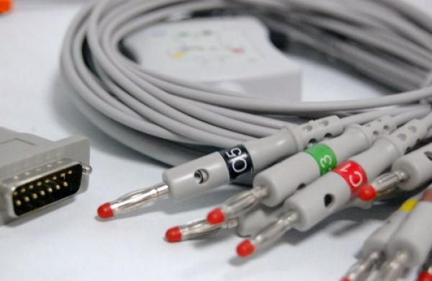

SCHILLER 10 LEAD EKG KABLOSU (4MM BANANA-IEC)

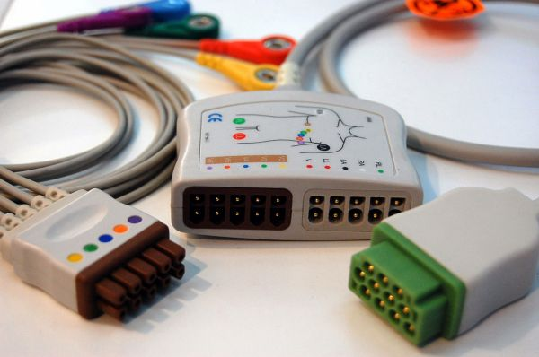

GE MARQUETTE 12 LEAD EKG KABLOSU VE LEAD TAKIMI

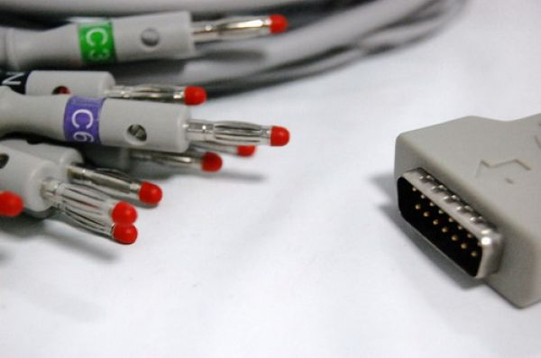

GE MARQUETTE 10 LEAD EKG KABLOSU (4MM BANANA-IEC)

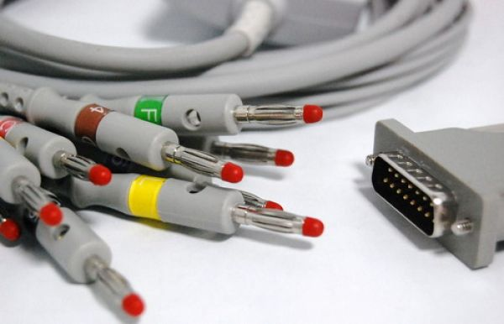

HP 10 LEAD EKG KABLOSU (4MM BANANA-IEC)

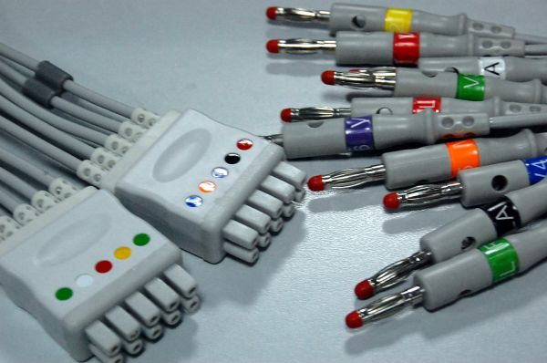

GE MARQUETTE LEAD TAKIMI (4MM BANANA)

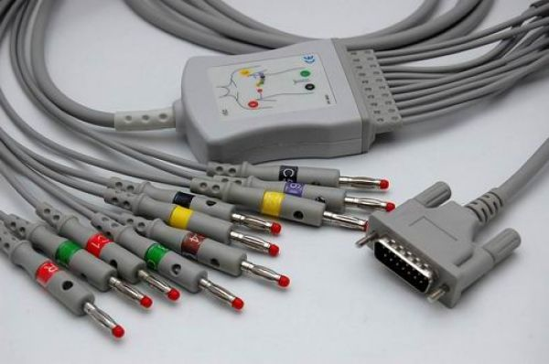

SCHILLER 10 LEAD EKG KABLOSU (4MM BANANA-IEC)

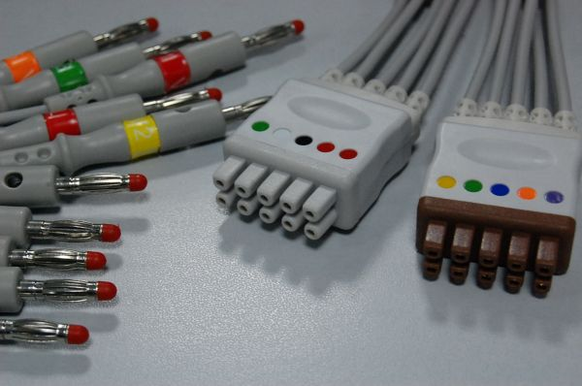

GE MARQUETTE LEAD TAKIMI (4MM BANANA)

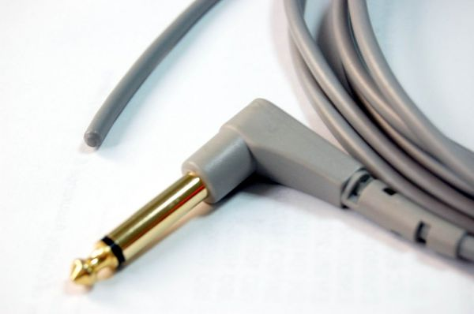

YSI 400 REKTAL ISI PROBU

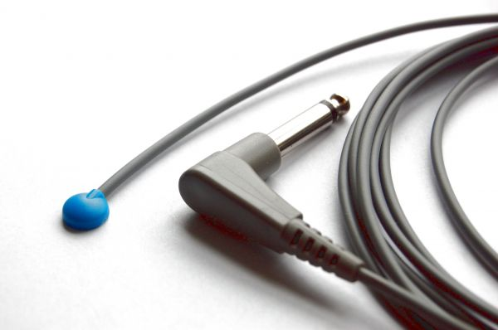

YSI 400 CİLT ISI PROBU

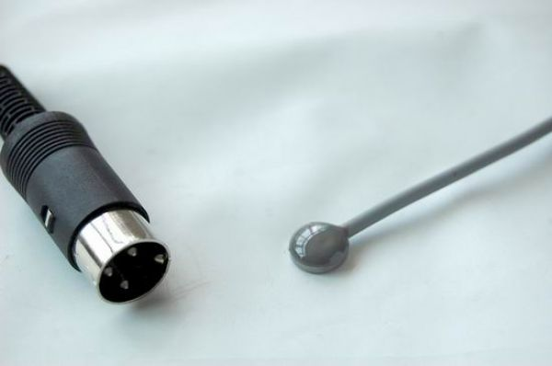

AIR SHIELDS CİLT ISI PROBU

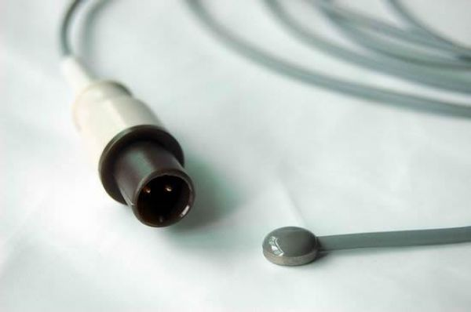

PHILIPS CİLT ISI PROBU

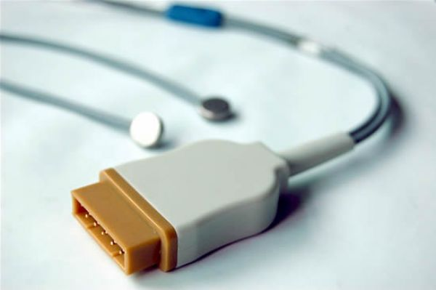

GE MARQUETTE CİLT ISI PROBU
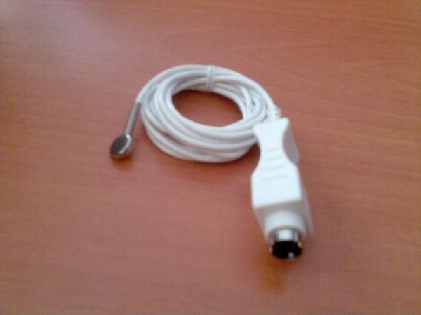

DRAGER / AIR SHIELDS CİLT ISI PROBU (C-2000)

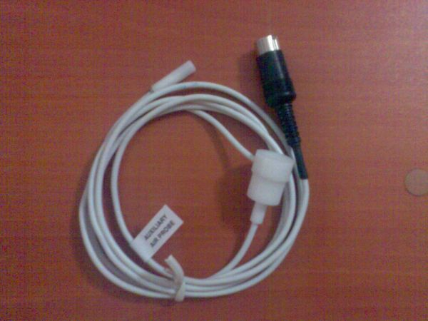

DRAGER / AIR SHIELDS HAVA ISI PROBU (C-450)
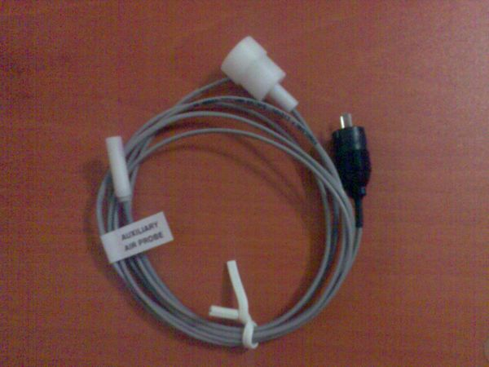

DRAGER / AIR SHIELDS HAVA ISI PROBU (C-100)

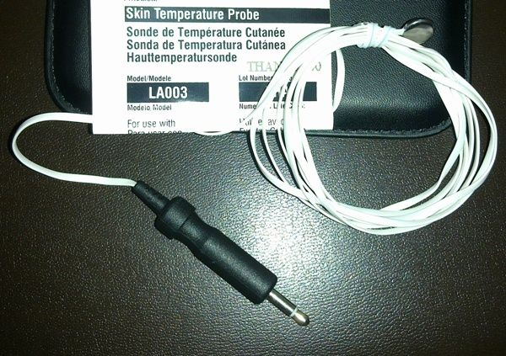

OHMEDA CİLT ISI PROBU

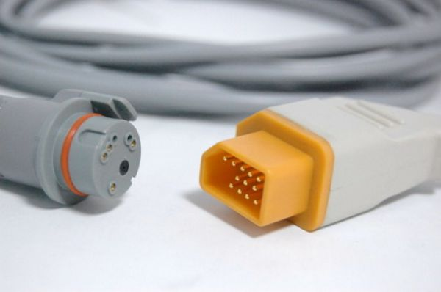

NIHON KOHDEN IBP KABLOSU (BD)

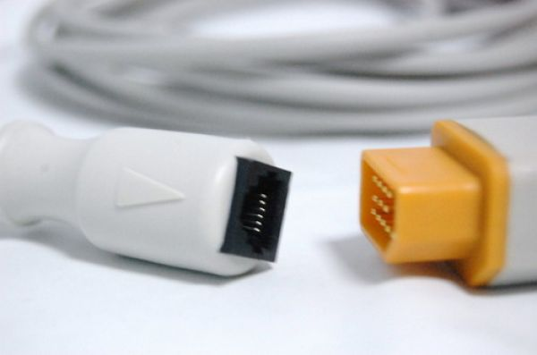

NIHON KOHDEN IBP KABLOSU (MEDEX ABBOTT)

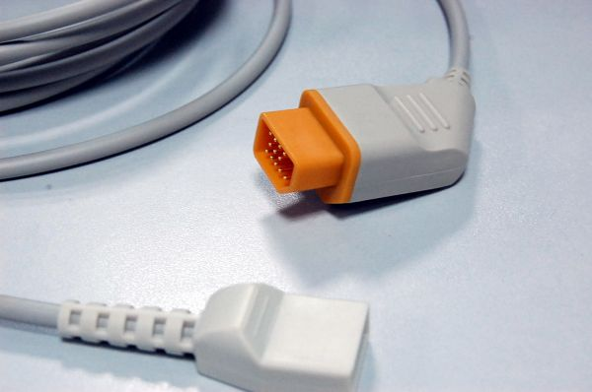

NIHON KOHDEN IBP KABLOSU (UTAH)

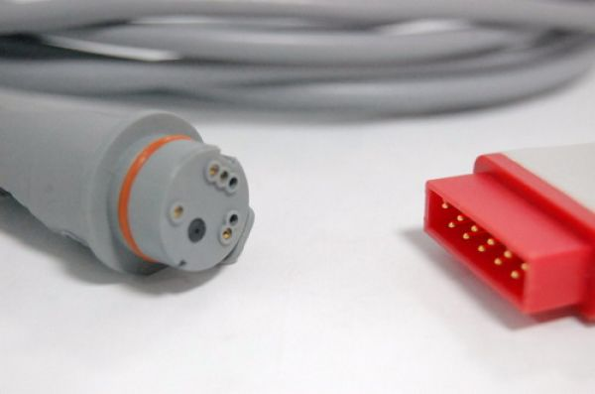

GE MARQUETTE IBP KABLOSU (BD)

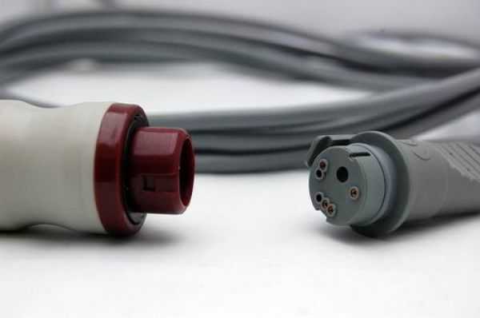

PHILIPS-HP IBP KABLOSU (BD)

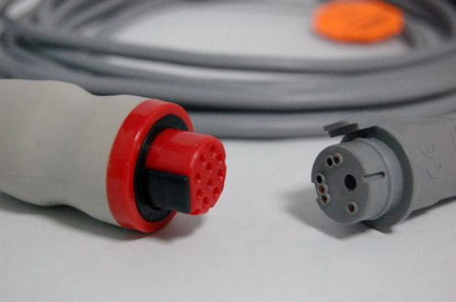

GE DATEX OHMEDA IBP KABLOSU (BD)

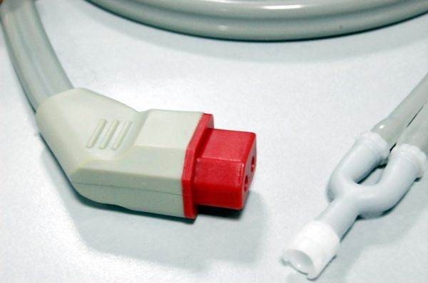

NIHON KOHDEN NIBP HORTUMU

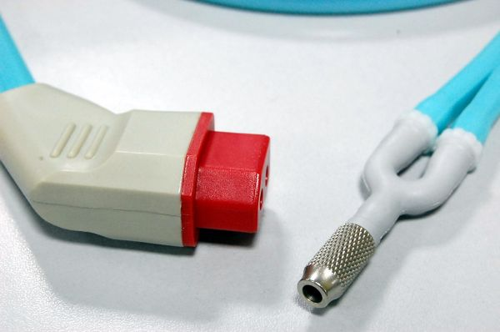

NIHON KOHDEN NIBP HORTUMU (PEDIATRIC)

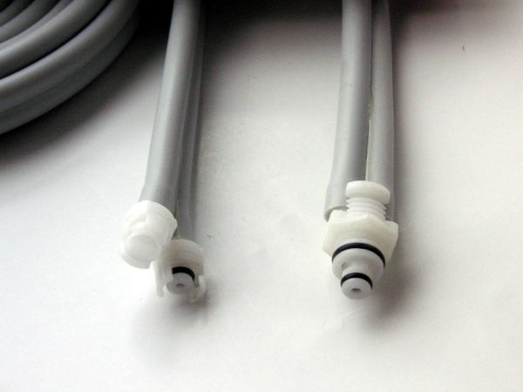

GE NIBP HORTUMU
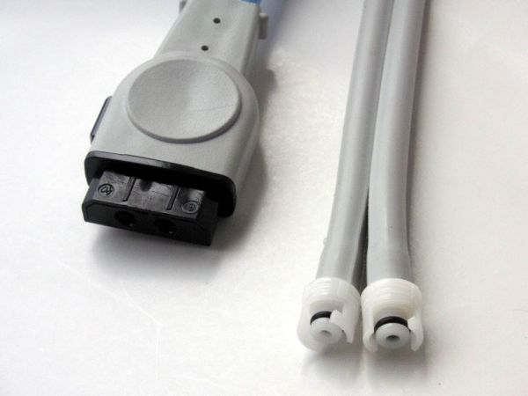

GE NIBP HORTUMU
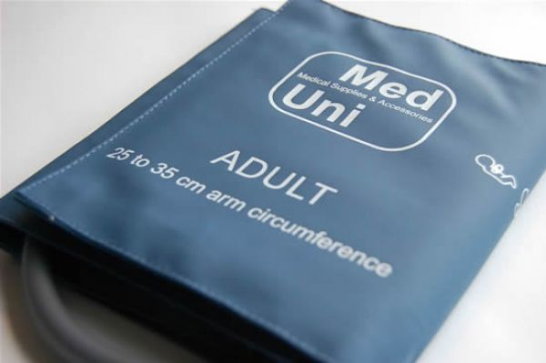

NIBP MANŞONU (25-35 CM ADULT-TEK HORTUMLU)

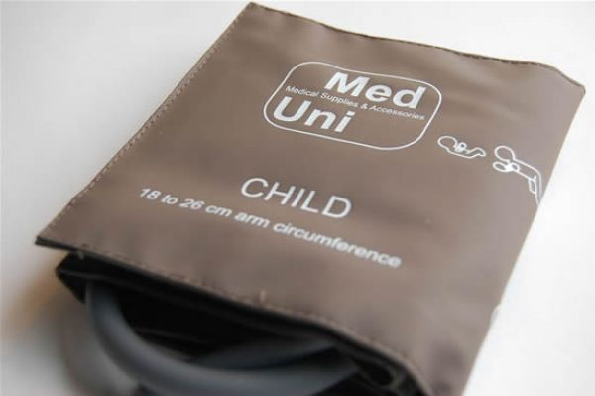

NIBP MANŞONU (18-26 CM PEDIATRIC-TEK HORTUMLU)

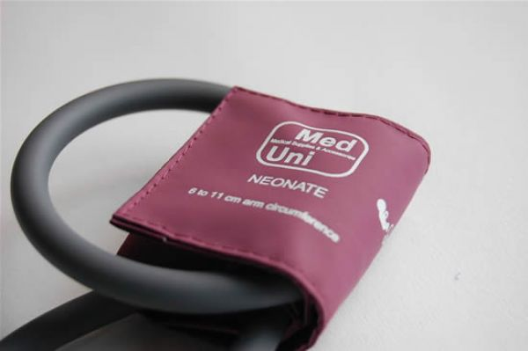

NIBP MANŞONU (6-11 CM NEONATE-TEK HORTUMLU)

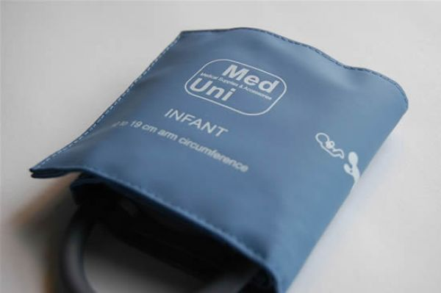

NIBP MANŞONU (10-19 CM INFANT-TEK HORTUMLU)

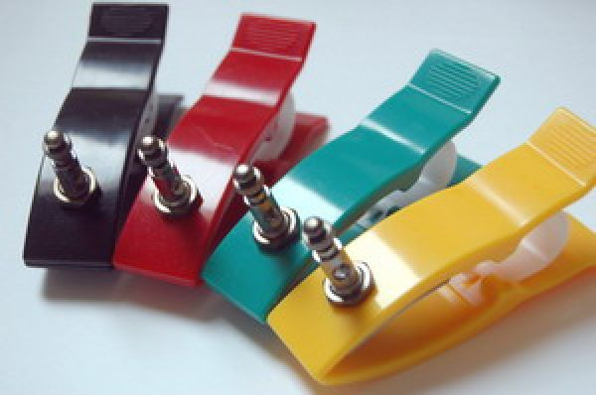

EKG MANDALI (PEDIATRIC)

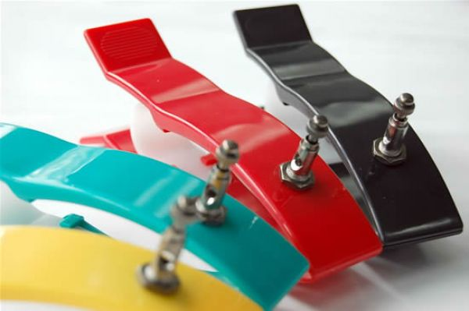

EKG MANDALI (ADULT)

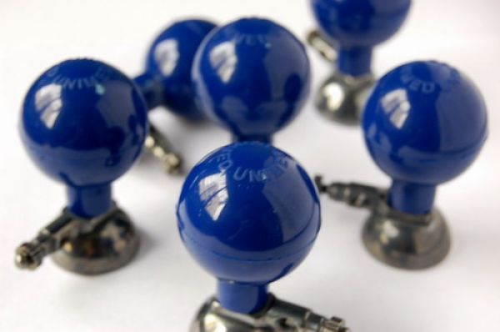

EKG PUARI (ADULT)

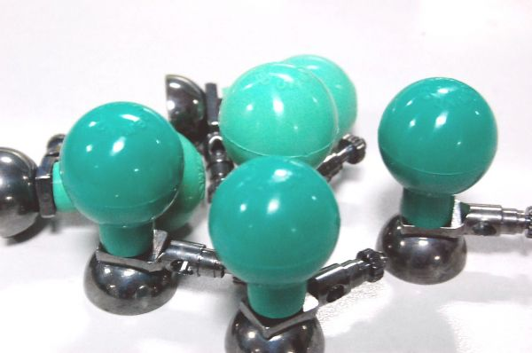

EKG PUARI (PEDIATRIC)

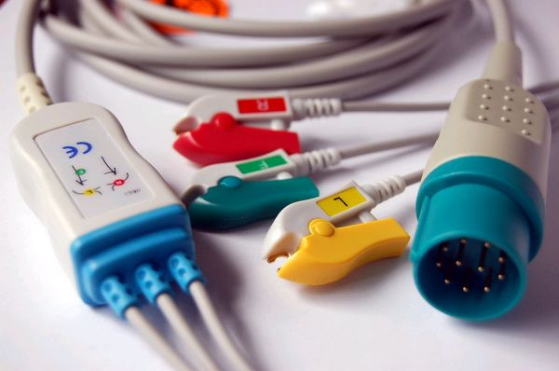

NIHON KOHDEN DEFİBRİLATÖR EKG KABLOSU 11 PİN (GRABBER-IEC)

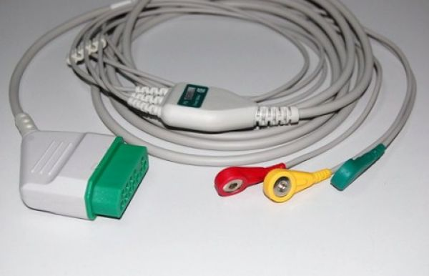

NIHON KOHDEN EKG KABLOSU (SNAP-IEC) komple

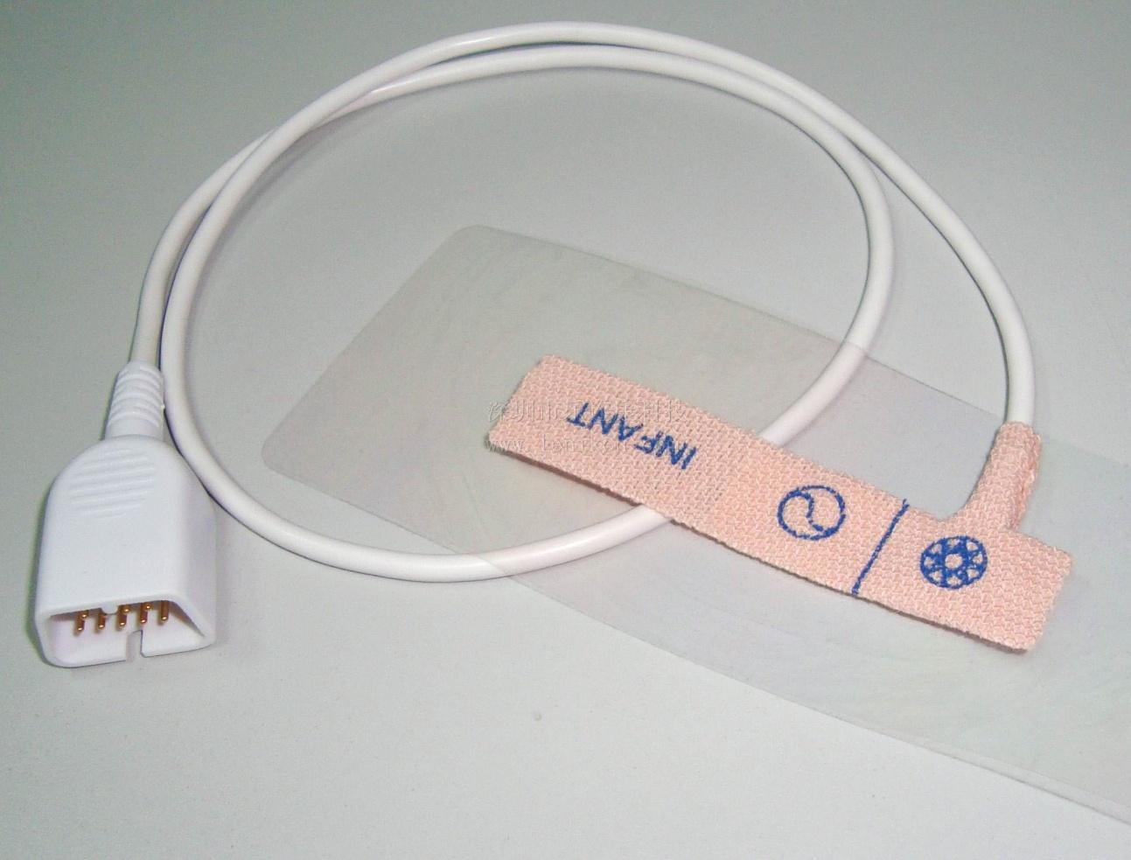NIHON KOHDEN TEK KULLANIMLIK SPO2 SENSORÜ İNFANT BSM SERİSİ İÇİN
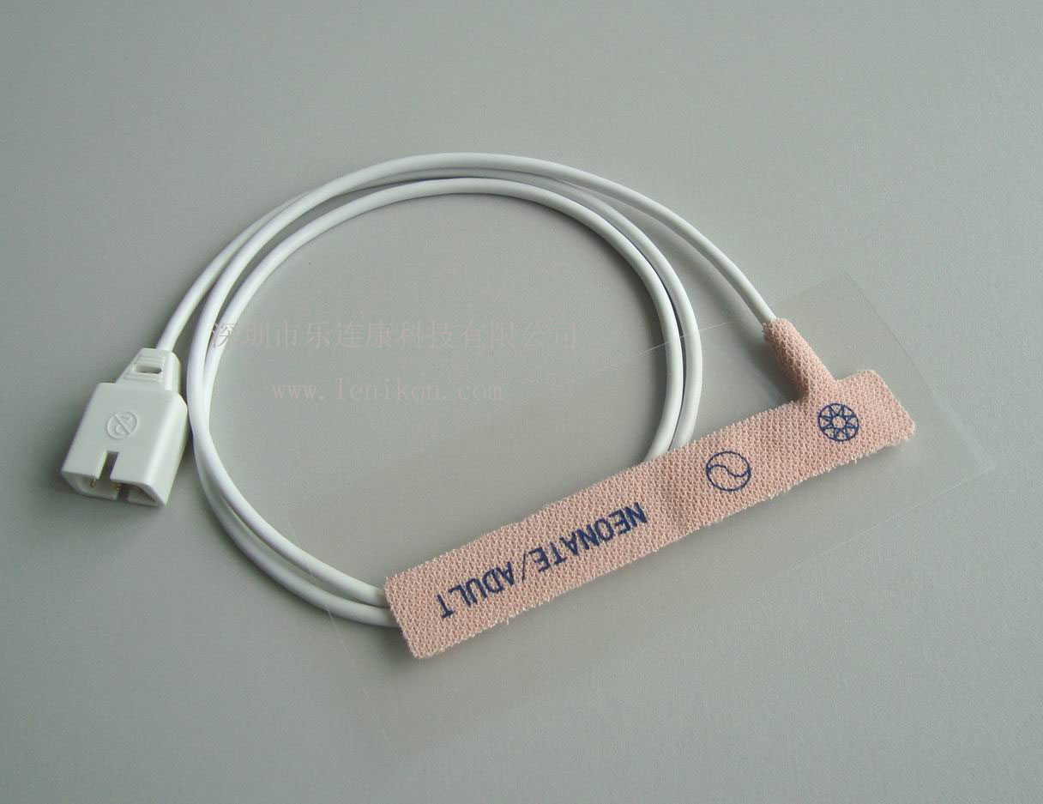
NELLCOR TEK KULLANIMLIK SPO2 SENOR
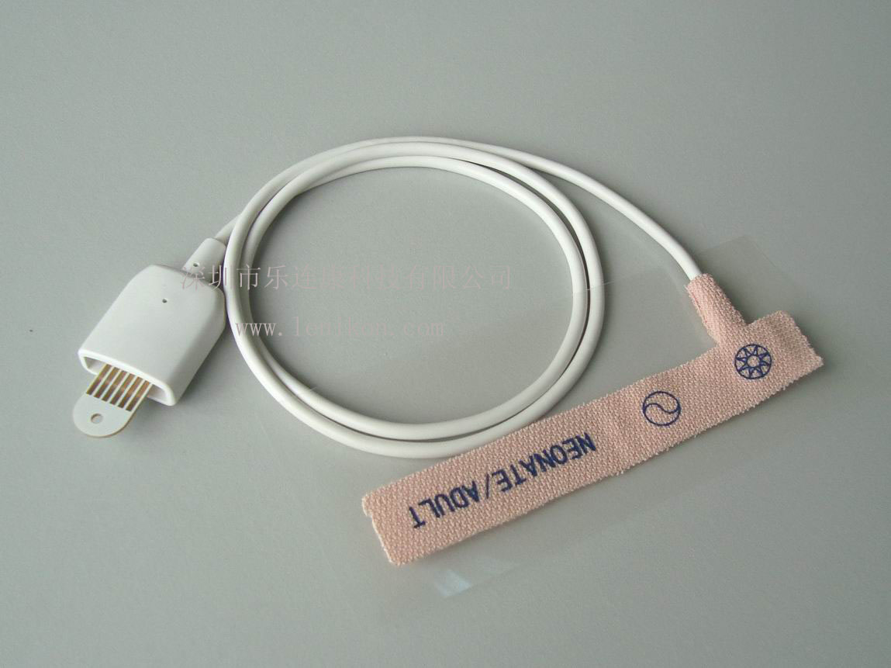MASIMO TEK KULLANIMLIK SPO2 SENSOR (KIZAKLI)

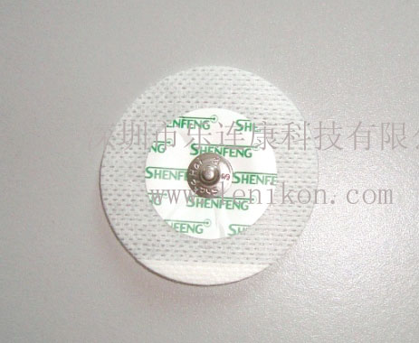TEK KULLANIMLIK EKG ELKTRODU (MEDEKS)
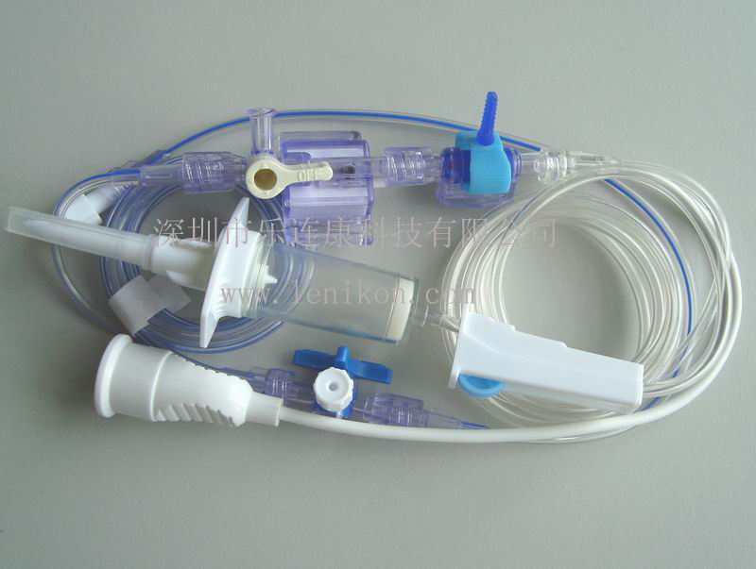IBP TRANSDUCER TEK KULLANIMLIK BD

